**Review Questions**

**1. Which of the following are examples of algorithms?**

a. A dictionary

b. A recipe

c. A set of instructions for putting together a utility shed

d. The spelling checker of a word processor

As a recipe (e.g. to bake a cake) has some input data (the ingredients), the instructions how to mix everything together and bake and even some output (the finished cake) we may look at it as an algorithm. **Therefore b.is correct.**

The same applies to a set of instructions to put together a utility shed -- we have the instructions.  Answer c.iscorrect.

The spelling checker of a word process is definitely an algorithm as it does have a finite set of well defined instructions to check our spelling. For this reason d.isalsocorrect.

**2. Which of the following contain information?**

a. My grandmother’s china cabinet

b. An audio CD

c. A refrigerator

d. A book

e. A running computer

d. A book: A book contains written or printed information in the form of text, images, or other content.

e. A running computer: A running computer processes and stores various forms of digital information, such as data, files, and software.

**3. Which of the following are general-purpose computing devices?**

a. A cell phone

b. A portable music player

c. A laptop computer

d. A programmable thermostat

General-purpose computing devices are those that can be used for a wide range of tasks and can run various software applications. Based on this definition, the following items are considered general-purpose computing devices:

a. A cell phone: Modern smartphones are versatile devices that can run various applications and are used for a wide range of tasks beyond just calling and texting.

c. A laptop computer: Laptops are designed for general-purpose computing and can run a wide variety of software applications.

The following items are not typically considered general-purpose computing devices:

b. A portable music player: While portable music players can perform specific tasks like playing music, they are not as versatile as general-purpose computing devices.

d. A programmable thermostat: Programmable thermostats are specialized devices designed for controlling heating and cooling systems in homes. They do not have the same level of general-purpose computing capabilities as cell phones or laptops.

**4. Which of the following are input devices?**

a. Speaker

b. Microphone

c. Printer

d. A mouse

As a**b**.**Microphone** is used to input a sound (usually voice) to be recorded on or transmitted via our computer, it is an input device.

**5. Which of the following are output devices?**

a. A digital camera

b. A keyboard

c. A flatbed scanner

d. A monitor

The only correct answer is **d.Amonitor** as the screen will show us what is happening in the computer and, for example show us output of our Python programs.

**6. What is the purpose of the CPU?**

a. Store information

b. Receive inputs from the human user

c. Decode and execute instructions

d. Send output to the human user

The CPU is responsible for performing calculations and executing instructions as part of a computer's processing tasks. It doesn't store information, receive inputs from the human user, or send output to the human user directly; those functions are typically handled by other parts of the computer, such as RAM and input/output devices.

**7. Which of the following translates and executes instructions in a programming**

**language?**

a. A compiler

b. A text editor

c. A loader

d. An interpreter

**d Aninterpreter** **.** is the correct answer. The answer a.Acompiler is not correct because the compiler translates the code into a low level language and doesnotrun(execute) the code

An interpreter is a software program that translates and executes instructions written in a programming language line by line, typically without the need for a separate compilation step. It reads the code, interprets it, and executes it directly, which allows for more dynamic and interactive development. Compiler (option a) also translates code but generates an intermediate or executable file that is run separately from the original source code. A text editor (option b) is a tool for writing and editing code but doesn't translate or execute code. A loader (option c) is responsible for loading executable files into memory but is not involved in translating or executing high-level programming language instructions.

**8. Which of the following outputs data in a Python program?**

a. The input statement

b. The assignment statement

c. The print statement

d. The main function

**The correct answer is c.**The print statement. The choice �.a. reads an input, .b. assigns a value to a variable and mainfunction forms a body of a progra

In Python, the "print" statement is used to output data to the console or other output streams. It allows you to display information, variables, and results to the user. The other options mentioned are not primarily used for outputting data:

a. The input statement is used for receiving input from the user. b. The assignment statement is used to assign values to variables. d. The main function is typically the entry point of a Python program and may contain the program's logic, but it doesn't inherently output data; you would still need to use the "print" statement or other output methods within the main function to display data.

**9. What is IDLE used to do?**

a. Edit Python programs

b. Save Python programs to files

c. Run Python programs

d. All of the above

The correct answer is d.All of the above as the IDLE Python environment supports all the listed functions.

**10. What is the set of rules for forming sentences in a language called?**

a. Semantics

b. Pragmatics

c. Syntax

d. Logic

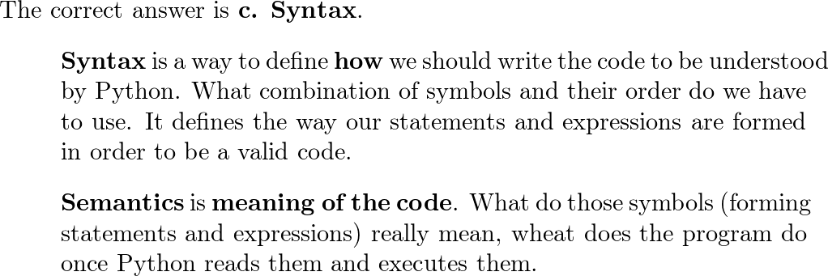

**Projects**

**1. Open a Python shell, enter the following expressions, and observe the results:**

a. 8

b. 8 * 2

c. 8 ** 2

d. 8/12

e. 8 // 12

f. 8/0

**2. Write a Python program that prints (displays) your name, address, and telephone number.**

print("salem alshehhi")

print("Dubai UAE")

print("05500005050")

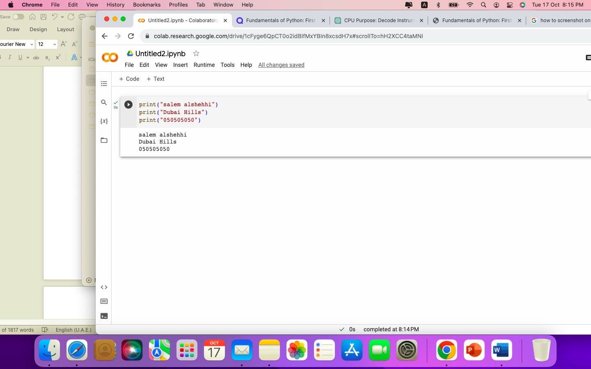

**3. Evaluate the following code at a shell prompt: print ("Your name is", name).**

**Then assign name an appropriate value, and evaluate the statement again.**

Run the Python shell and see what will happen once the code from the book gets executed:

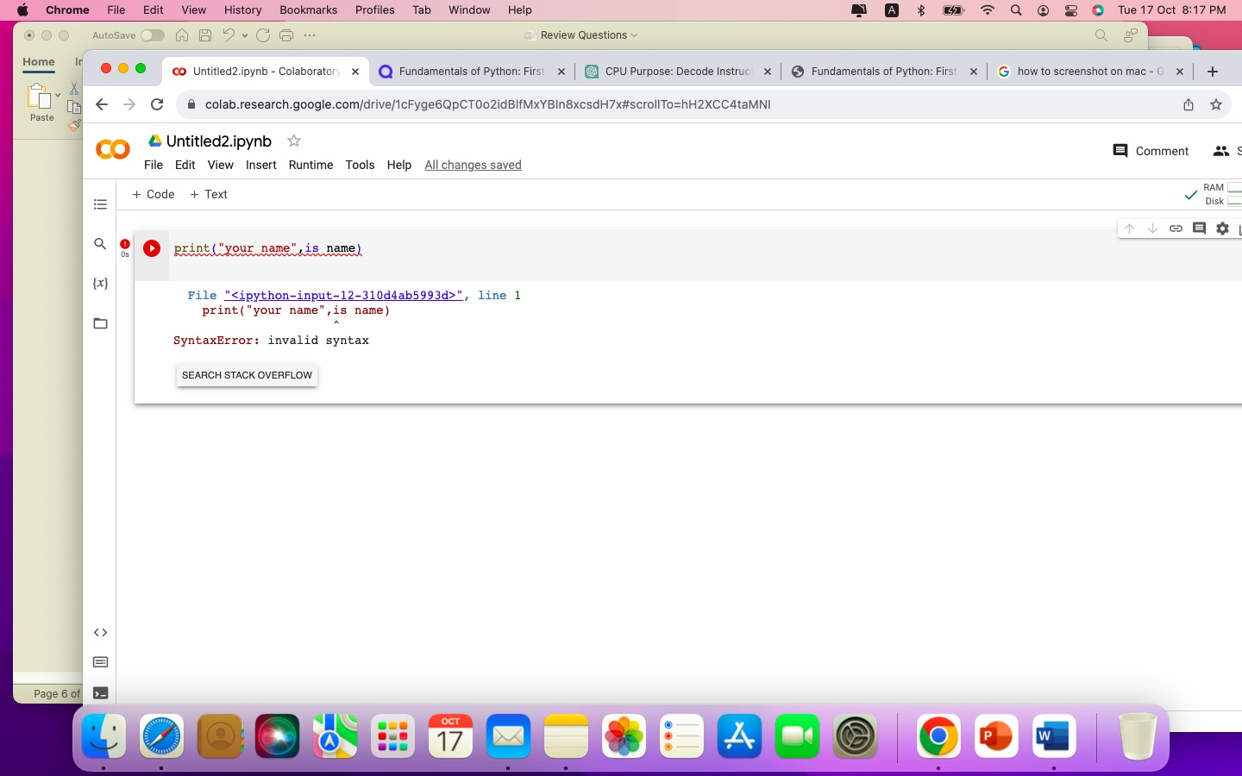

>>> print ("Your name is", name)

Traceback (most recent call last):

File "<stdin>", line 1, in <module>

NameError: name 'name' is not defined

We can see there’s an error because the name variable is not defined. Let’s define it first before executing the print() statement.

>>> name = "Salem"

>>> print ("Your name is", name)

Your name is Salem

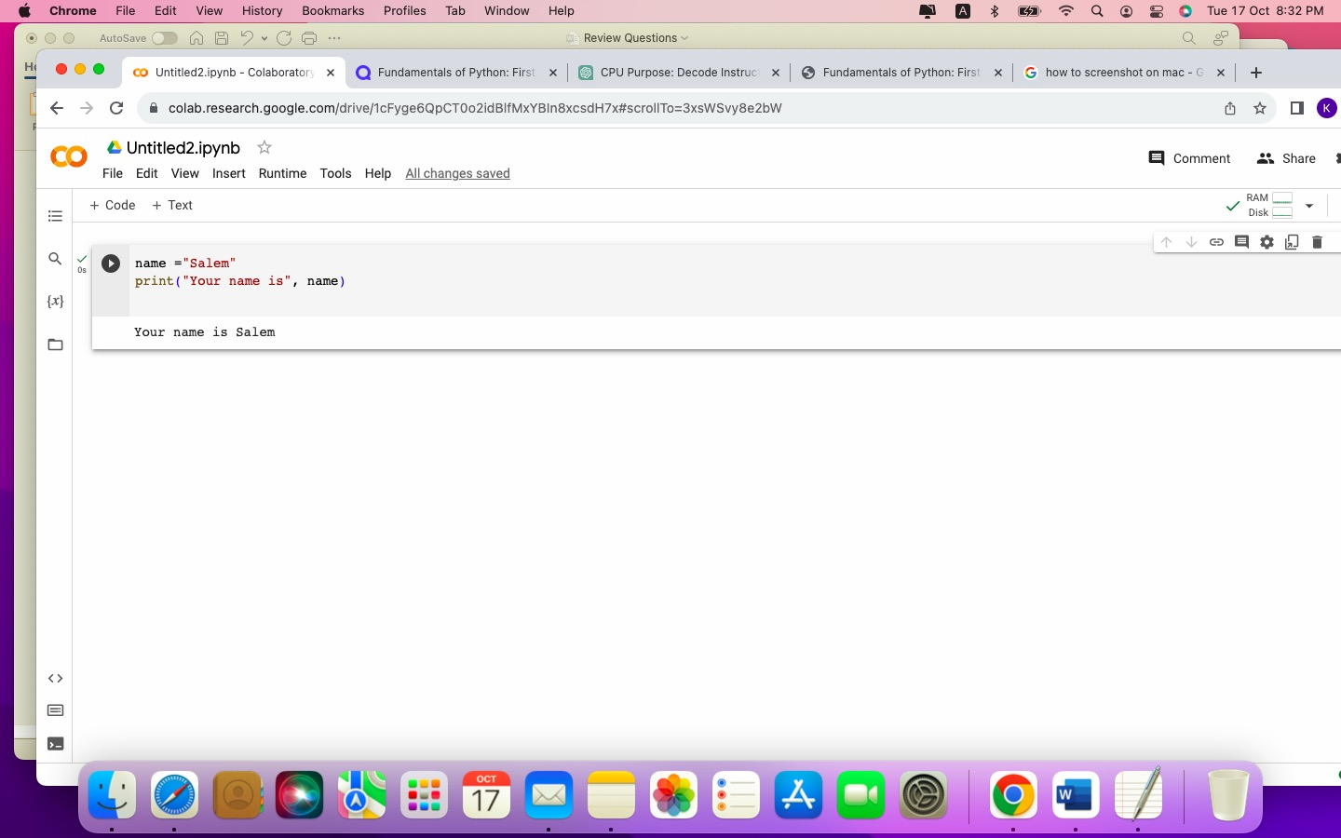

**4. Open an IDLE window, and enter the program from Figure 1-7 that computes**

**the area of a rectangle. Load the program into the shell by pressing the F5 key,**

**and correct any errors that occur. Test the program with different inputs by**

**running it at least three times.**

width = int(input("Enter with width: "))

height = int(input("Enter with height: "))

area = width * height

print("The area is", area, "square units.")

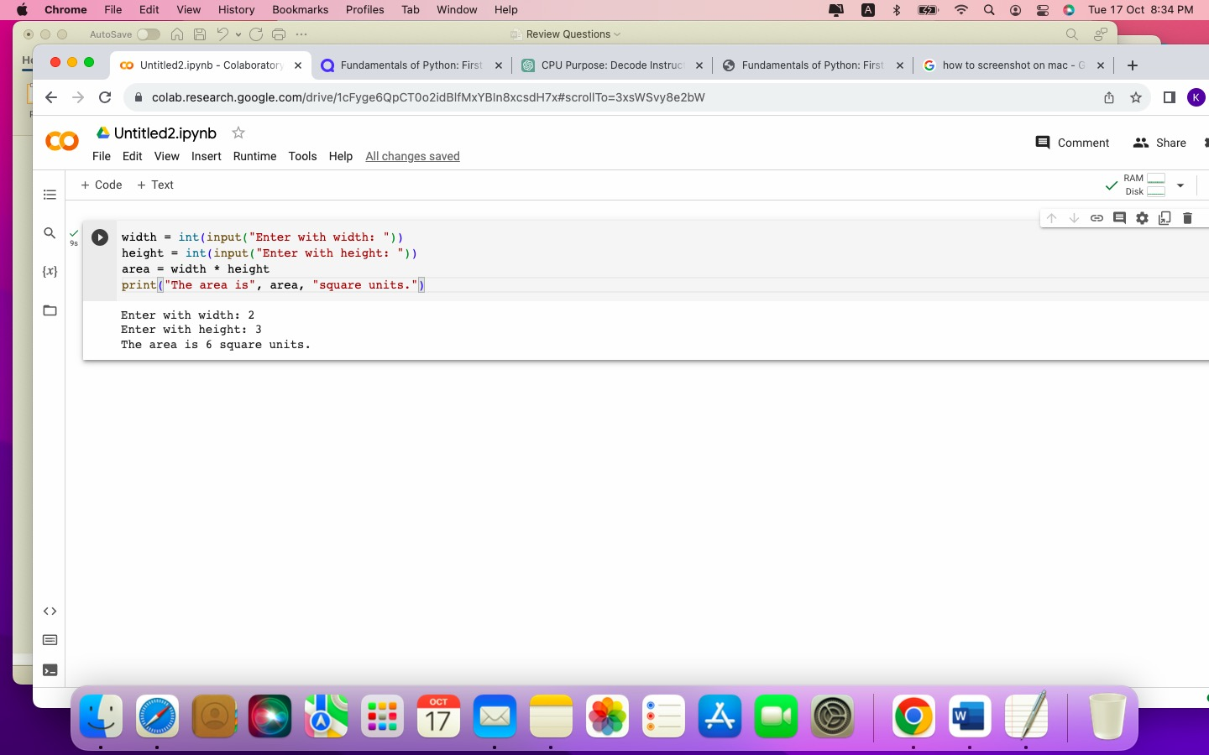

This would be the output for inputs 2 and 3:

Enter with width: 2

Enter with height: 3

The area is 6 square units.

Enter with width: 0

Enter with height: 5

The area is 0 square units.

As you can see in the following example, as we do not have any input check implemented, we’ll receive even an invalid negative area result when we enter a negative width value.

Enter with width: -5

Enter with height: 2

The area is -10 square units

**5. Modify the program of Project 4 to compute the area of a triangle. Issue the**

**appropriate prompts for the triangle’s base and height, and change the names of**

**the variables appropriately. Then, use the formula .5 * base * height to compute the area. Test the program from an IDLE window.**

The modification will be simple as we already have a code in place to read the inputs and print out the result from *Solution 4*. We just need to update the computation formula and change the variable width name to base.

base = int(input("Enter the triangle base: "))

height = int(input("Enter the triangle height: "))

area = 0.5 * base * height

print("The area is", area, "square units.")

Once executed, this would be the output for values 2 and 3:

Enter the triangle base: 4

Enter the triangle height: 3

The area is 6.0 square units.

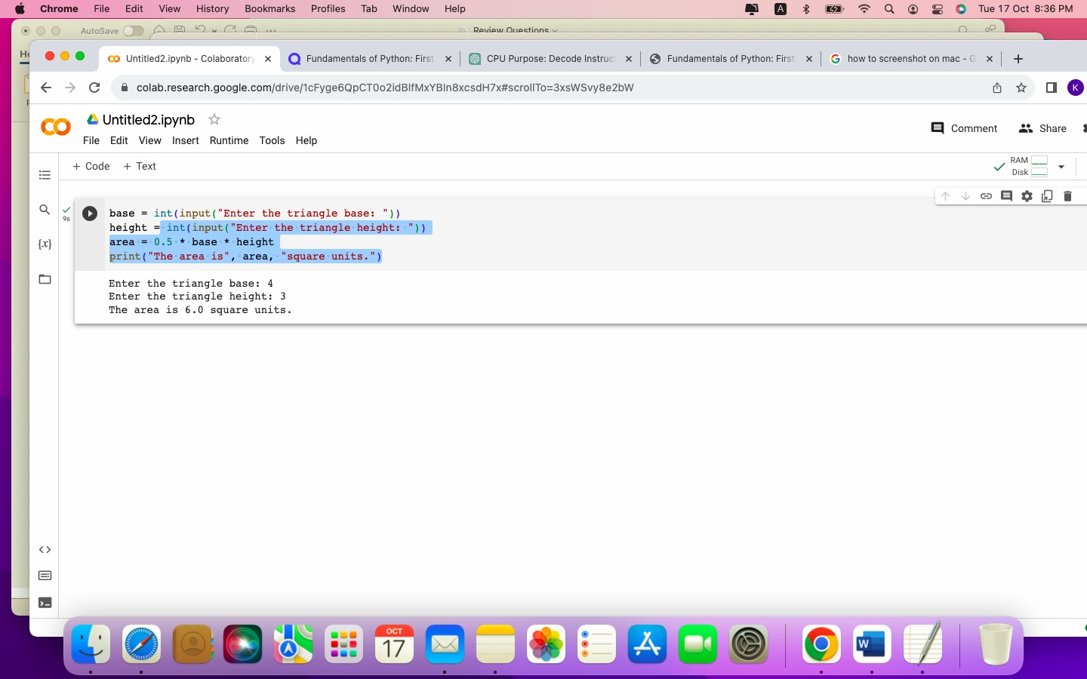

**6. Write and test a program that computes the area of a circle. This program should**

**request a number representing a radius as input from the user. It should use the formula**

**3.14 * radius ** 2 to compute the area and then output this result suitably labeled.**

The approach to writing this program is the same as in Solution 4 or 5 as we just need to read (this time just one) input from the user, do a simple computation using a formula and then printing the result out. The program might look like this:

radius = int(input("Enter the circle radius: "))

area = 3.14 * radius ** 2

print("The area is", area, "square units.")

The output would then look like this:

Enter the circle radius: 2

The area is 12.56 square units.

**7. Write and test a program that accepts the user’s name (as text) and age (as a number)**

**as input. The program should output a sentence containing the user’s name and age.**

This time, we need to read two variable values which have a different data type. The name variable will be a string, and the age variable will be an integer. Then we’ll just print those values out.

name = input("Enter your name: ")

age = int(input("Enter your age: "))

print("Your name is", name, "and your age is", age)

Please note that we do not use an explicit type conversion when reading name as string is the default data type when reading the user input. This is the testing output of our program:

**8. Enter an input statement using the input function at the shell prompt. When the**

**prompt asks you for input, enter a number. Then, attempt to add 1 to that number, observe the results, and explain what happened.**

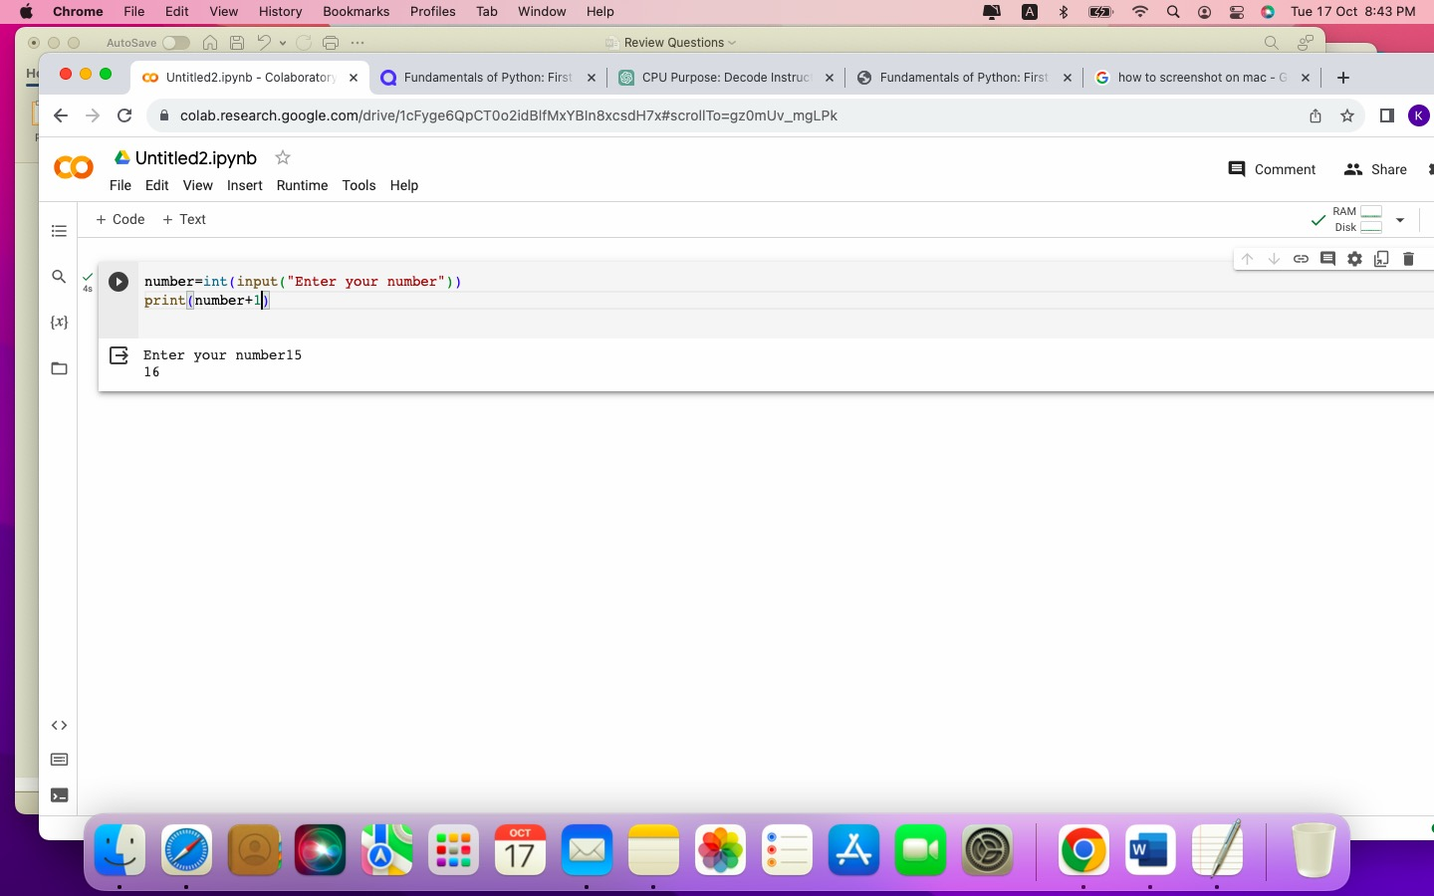

**9. Enter an input statement using the input function at the shell prompt. When the**

**prompt asks you for input, enter your first name, observe the results, and explain**

**what happened.**

>>> input("Enter your first name: ")

Enter your first name: salem

'salem'

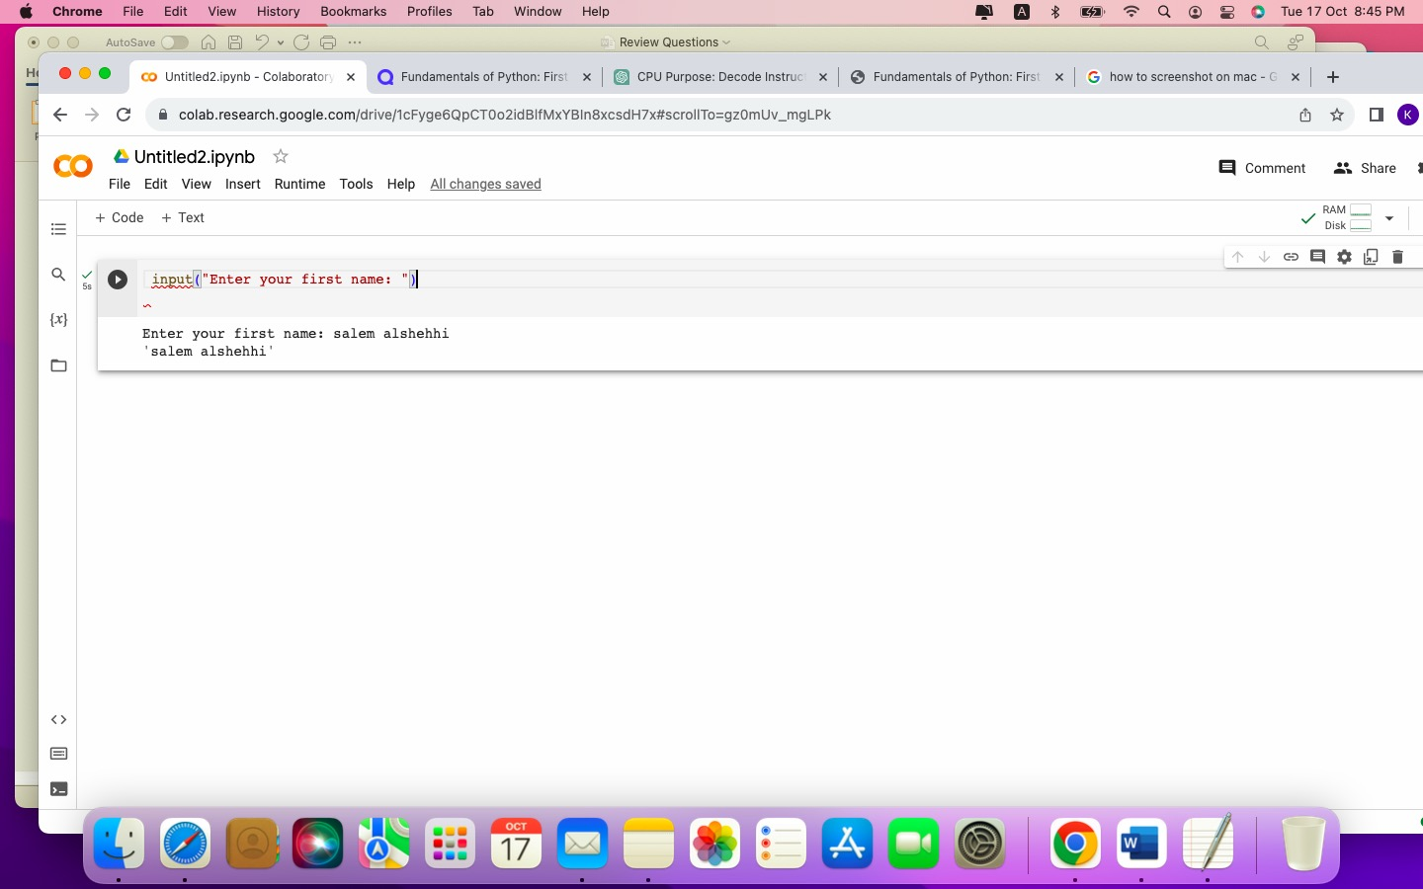

Python shell printed out the result of the  ()input() function right to the shell.

**10. Enter the expression help() at the shell prompt. Follow the instructions to**

**browse the topics and modules**